**1a.**

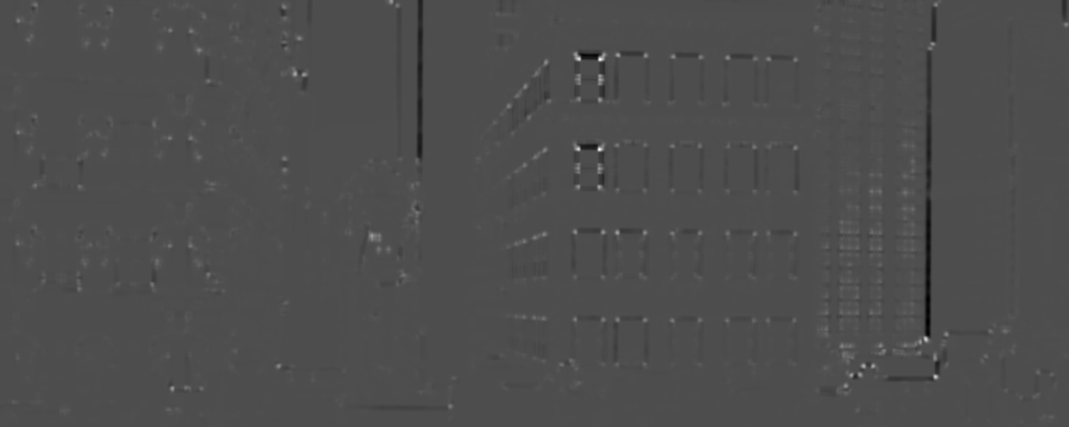

Harris method

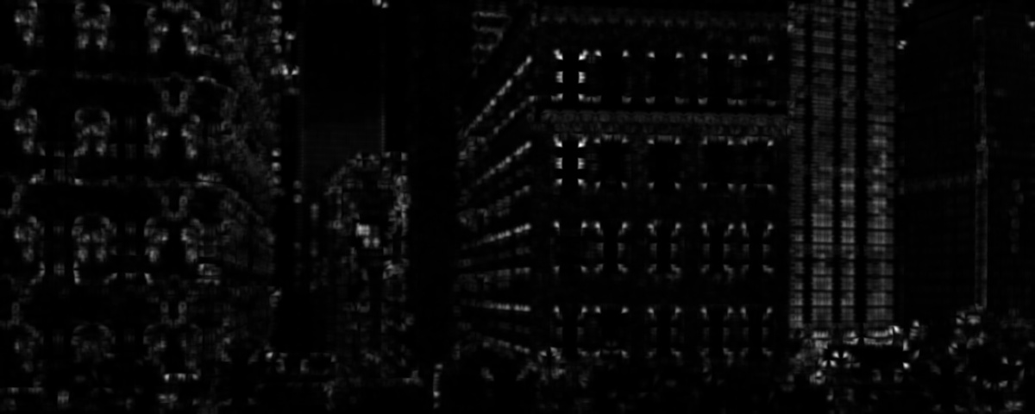

Brown method

Brown’s method is better than Harris method because Brown’s shows more corners and there are accurate.

**1b.** As r gets bigger, the number of corners decrease, and the corners are less condensed in an area. This is because r increases, hence the area of non-maximum suppression increases. (i.e. choose only one corner from a larger area). The number of corners decreases.

|  |  |
| --- | --- |
| Nms_Brown_r=5 |  |
| Nms_Brown_r=10 |  |
| Nms_Brown_r=15 |  |
| Nms_Brown_r=20 |  |

**1c.** k=1.1, sigma=1.3, layers=40, threshold=20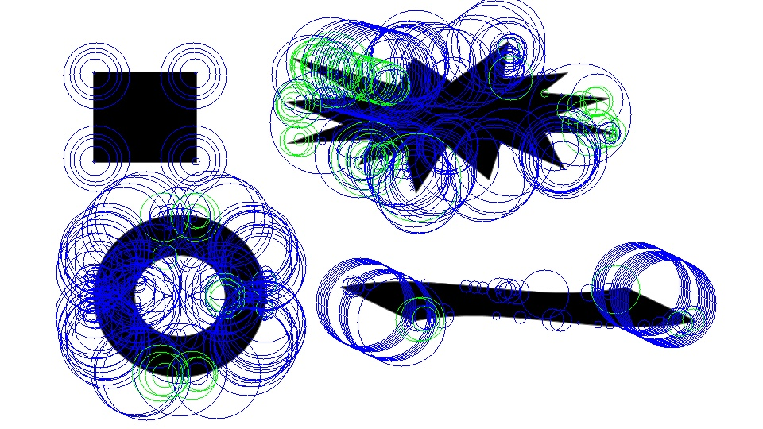

**1d.** I use SURF algorithm to detect feature points because it is faster than SIFT. It is Speeded-Up Robust Features. It is basically a speeded-up version of SIFT. We know SIFT did a great job in detecting images’ features, but it is a bit slow. SURF approximates LoG with Box Filter. Convolution with box filter can be calculated with the help of integral images and can be calculated in parallel, thus speed up the process.

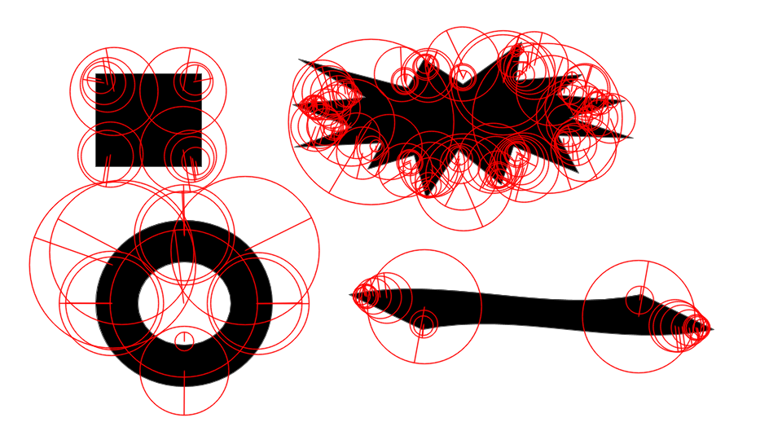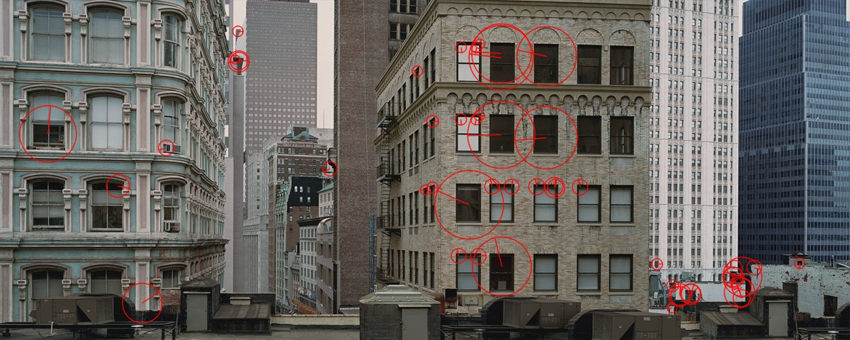

**2a.**

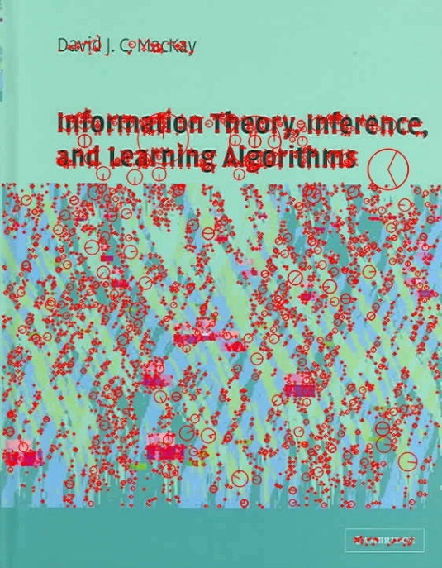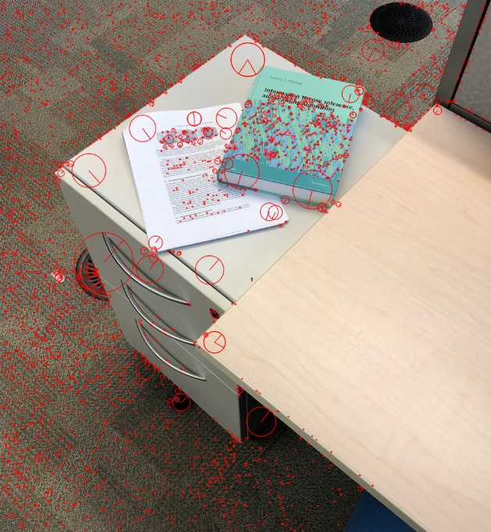

**2b.**

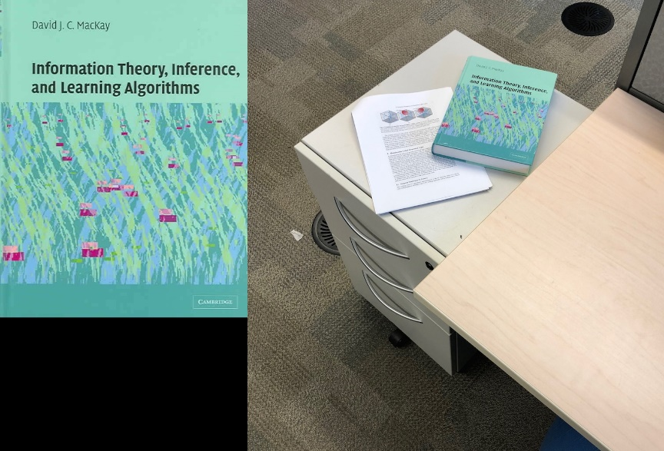

Threshold = 0.3(no match)

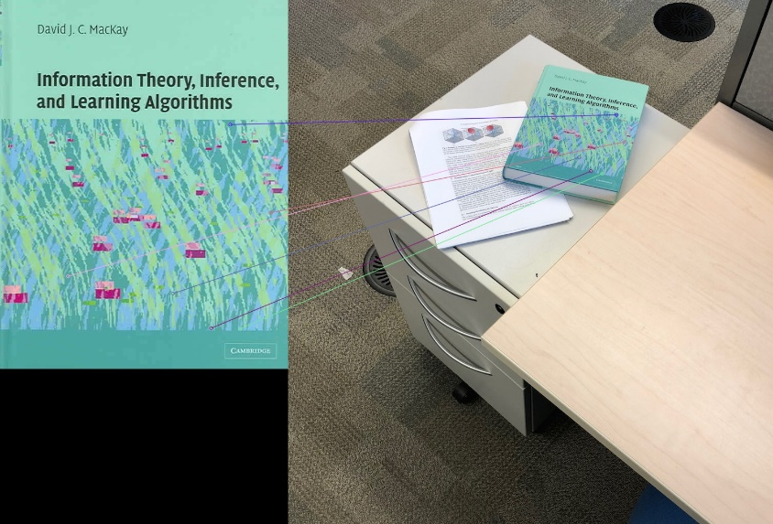

Threshold=0.4(under match)

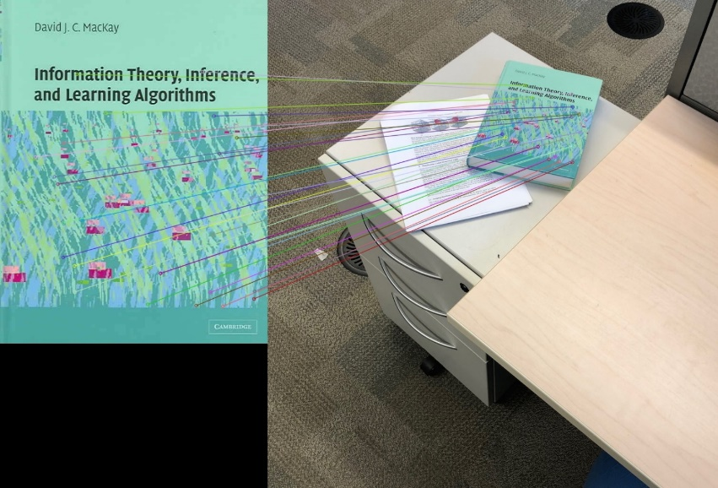

Threshold = 0.48

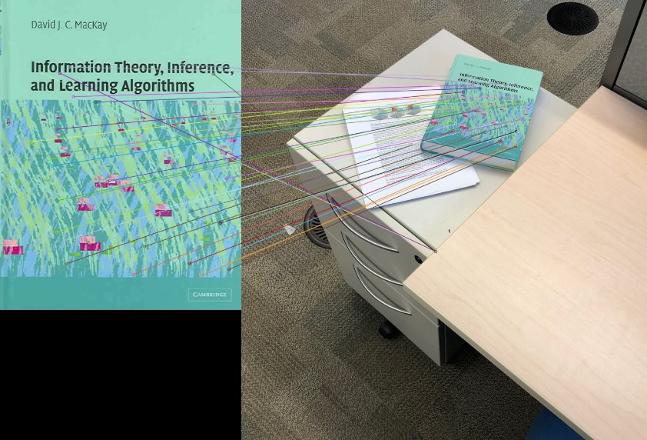

Threshold=0.5 (overmatch)

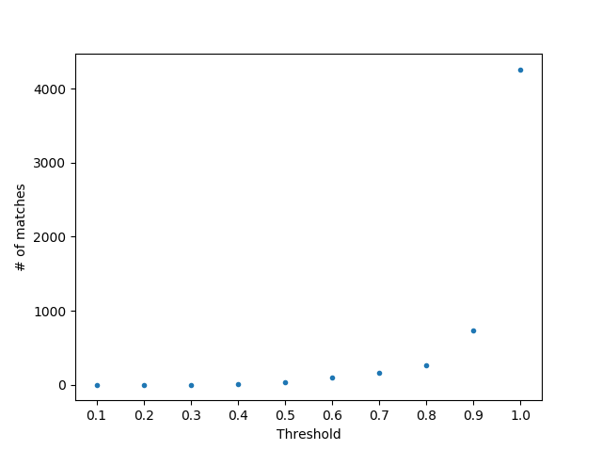

**2c. 2d.**

The minimum k required for solving the transformation is 3. The best k in my trials is k=20 for the best transformation.

|  |  |
| --- | --- |
| K=3 | [ 3.907e-01 -1.015e-01 8.313e-02 2.760e-01 4.946e+02 1.227e+02] |
| K=5 | [ 3.916e-01 -1.019e-01 8.359e-02 2.756e-01 4.946e+02 1.227e+02] |
| K=7 | [ 3.897e-01 -1.009e-01 8.771e-02 2.728e-01 4.947e+02 1.223e+02] |
| K=10 | [ 3.845e-01 -9.528e-02 8.044e-02 2.809e-01 4.931e+02 1.197e+02] |
| K=15 | [ 3.831e-01 -9.582e-02 7.994e-02 2.815e-01 4.940e+02 1.192e+02] |
| K=20 | [ 3.806e-01 -9.483e-02 8.068e-02 2.815e-01 4.944e+02 1.188e+02] |

|  |  |
| --- | --- |
| K=3 |  |
| K=5 |  |
| K=7 |  |
| K=10 |  |
| K=15 |  |
| K=20 |  |

**2e.** I extend the 3 RGB channels to the length=128 descriptors and become length=131. Add RGB value as an additional feature to the descriptors of the pixels. Thus, take colour into account.

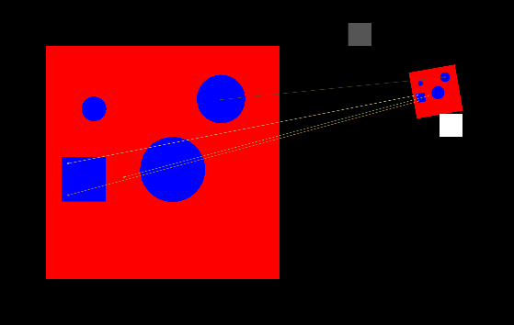

RGB considered.

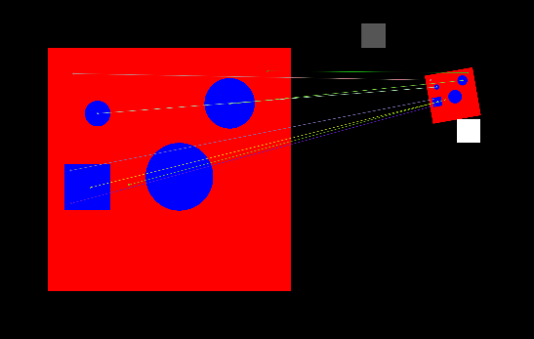

RGB not considered

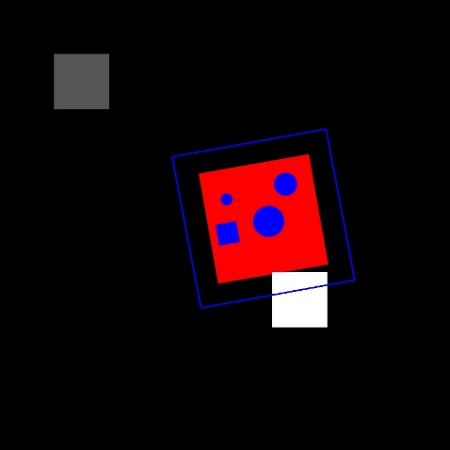

Transform (RGB considered)

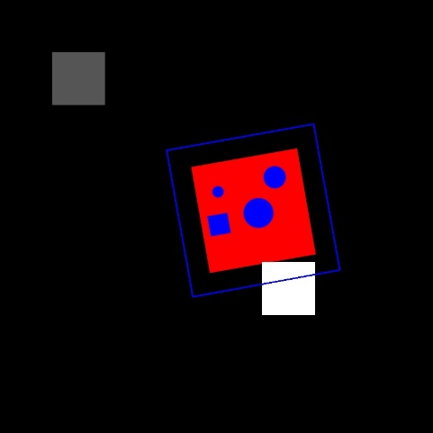

Transform (RGB not considered)

**3a.**

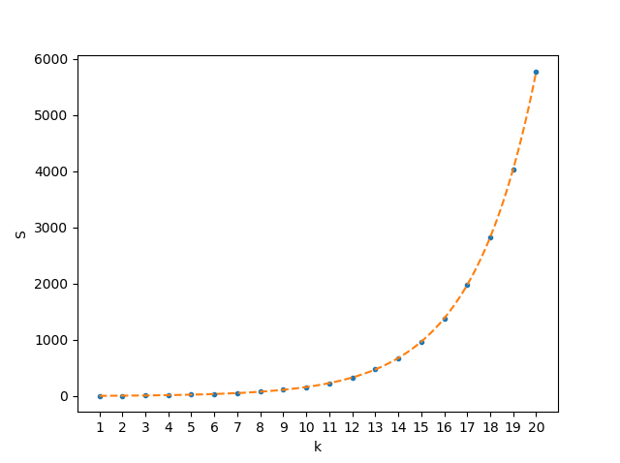

**3b.**

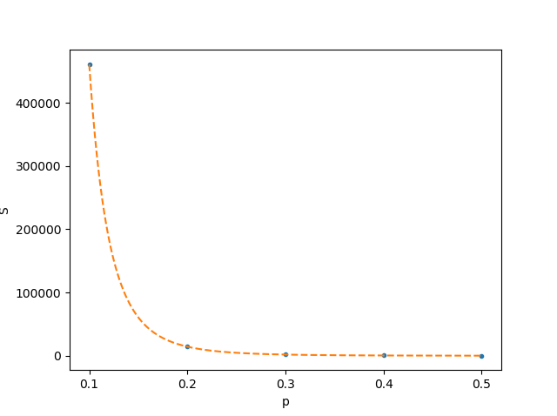

**3c.** The required number of iterations to recover the correct model with P>=0.99 chance is 14389. The number of required iterations will not change because this is only one iteration, we need to find the hypothesis that gives us the largest number of inliers.